- Word Cloud Generation (currently not available in nltk).

# Install wordcloud if you do not have it already.
!pip install wordcloud
# Import required libraries.
import nltk
from wordcloud import WordCloud
import matplotlib.pyplot as plt
from nltk.corpus import stopwords
from nltk.tokenize import word_tokenize
# Download data.
nltk.download('punkt')
nltk.download('stopwords')
# Write necessary functions.
def text_preprocessor(text):
"""
Tokenize and remove stopwords.
Args:
text (str): The imput text.
Returns:
str: The preprocessed text.
"""
tokens = word_tokenize(text.lower())
filtered_tokens = [word for word in tokens if word.isalnum() and word not in stopwords.words('english')]
return ' '.join(filtered_tokens)
def word_cloud_generator(text):
"""
Generate and display word cloud.
Args:
text (str): The preprocessed text.
"""
wordcloud = WordCloud(width=800, height=400, background_color='white').generate(text)
plt.figure(figsize=(8, 5))
plt.imshow(wordcloud, interpolation='bilinear')
plt.axis('off')
plt.show()
def main():
# Sample text document.
sample_text = """
Word Cloud Generation (WSG) is an influential visual tool that is used in text analytics.
It represents the most frequent words available within an input text document.
Words appearing more frequently are displayed in larger, bolder fonts.
This type of visual representation of words helps to quickly categorise the central themes and key terms.
Word clouds are often used by the NLP community for exploratory data analysis EDA).
Word clouds are predominantly used in summarizing large texts documents.
However, word clouds do not reveal the context in which words appear.
Despite this major limitation, word clouds are popularly for initial text exploration (EDA).
"""
# Preprocess the sample text.
pre_processed_text = text_preprocessor(sample_text)
# Generate the word cloud.
word_cloud_generator(pre_processed_text)
if __name__ == "__main__":
main()
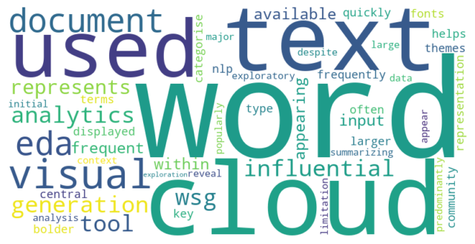
Code Snippet 4.14

